

|  |
| --- |
| CS 1103 - FR02B  Assignment 5 |
| By Ngoc Phuong Anh Nguyen - 3712361  March 2021 |

# **Review Questions:**

## Question 2: Explain why it might be more appropriate to declare an attribute that contains only digits as a character data type instead of a numeric data type.

The attributes are declared as numeric data types only when they must do some mathematical functions. Some attributes as phone numbers, security codes do not have to do that, so they should be declared as character data types.

## Question 5: What is the purpose of a CHECK constraint?

A CHECK constraint is used to validate data when an attribute value is entered.

## Question 7: What is the difference between an INSERT command and an UPDATE command?

* INSERT command is used to add new data in a table, while UPDATE command is used to modify data in a table.
* An UPDATE statement can use a WHERE clause, but INSERT cannot.

# Problems:

## 1. Using Figure P7.1 in the text as a guide, write the SQL/DDL to create the Job and EMPLOYEE tables Note the cardinality requirements for the relationship indicates a foreign key and values are required. Write the SQL commands to add the first three records to the JOB table and the first three records to the EMPLOYEE table. Consider using your personal database (mysql> use <username>;) on cs1103.cs.unb.ca to test your work.

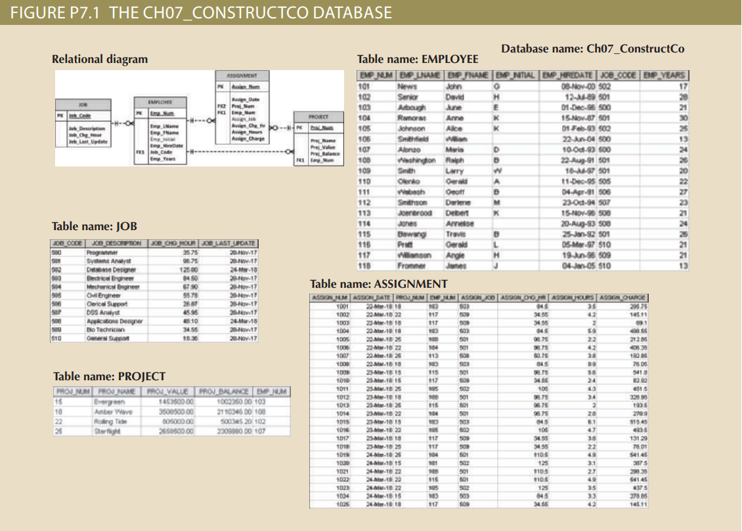

Figure 1: The Ch07_ConstructCo Database

### Create JOB table:

CREATE TABLE JOB

(

JOB_CODE VARCHAR(3),

JOB_DESCRIPTION VARCHAR(50),

JOB_CHG_HOUR DECIMAL(10,2),

JOB_LAST_UPDATE DATE,

PRIMARY KEY(JOB_CODE)

);

### Create EMPLOYEE table:

CREATE TABLE EMPLOYEE

(

EMP_NUM VARCHAR(3),

EMP_LNAME VARCHAR(15),

EMP_FNAME VARCHAR(15),

EMP_INITIAL VARCHAR(1),

EMP_HIREDATE DATE,

JOB_CODE VARCHAR(3),

EMP_YEARS INT(3),

PRIMARY KEY(EMP_NUM),

FOREIGN KEY(JOB_CODE)

REFERENCES JOB(JOB_CODE)

ON DELETE NO ACTION

ON UPDATE CASCADE

);

### Insert the first three records to the JOB table:

INSERT INTO JOB

VALUES('500','Programmer',35.75,'2017-11-20');

INSERT INTO JOB

VALUES('501','Systems Analyst',96.75,'2017-11-20');

INSERT INTO JOB

VALUES('502','Database Designer',125.00,'2018-03-24');

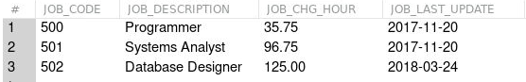

Figure 2: Output result of the JOB table

### Insert the first three records to the EMPLOYEE table:

INSERT INTO EMPLOYEE

VALUES('101', 'News', 'John', 'G','2000-11-08','502',17);

INSERT INTO EMPLOYEE

VALUES('102', 'Senior', 'David', 'H','1989-07-12','501',28);

INSERT INTO EMPLOYEE

VALUES('103', 'Arbough', 'June', 'E','1969-12-01','500',21);

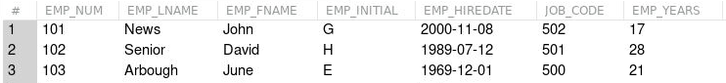

Figure 3: Output result of the EMPLOYEE table

## 2. What happens if you create the EMPLOYEE table before the JOB table? Why?

If we create the EMPLOYEE table before the JOB table, the tables are not going to be created, because the foreign key in EMPLOYEE table references to JOB_CODE in JOB table, but it has not existed yet.

## 3. What happens if you add an employee record with a JOB _CODE not present in the JOB table? Why?

If we add an EMPLOYEE record with a JOB_CODE which does not present in the JOB table, the action cannot be done. Because that JOB_CODE record does not exist in the JOB table, it does not reference to there.